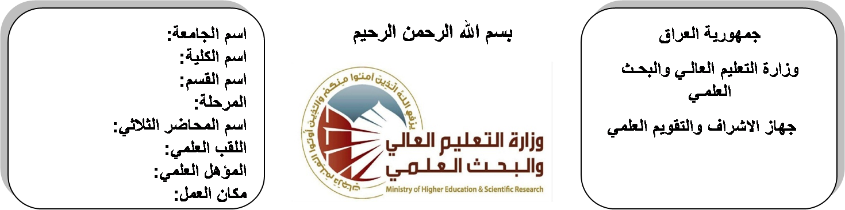

**Republic of Iraq**

**Ministry of Higher Education**

**& Scientific Research**

**University: Diyala University**

**College: College of Engineering**

**Department: Electronic Engineering**

**Stage: third**

**Lecturer name:** Isam Salah Hameed Khamees

**Qualification: M.Sc**

**Place of work: Electronic Dept.**

**(( Annual teaching plan form))**

|  |  |  |  |  |
| --- | --- | --- | --- | --- |
| **Lecturer Name** | Isam Salah Hameed Khamees | | | |
| **Email** | **husamtakt@yahoo.com** | | | |
| **Subject** | Microelectronics | | | |
| **Aims** | **The aim of this subject is to make the students ready to undestand and comprehend the scientific theories and their applications related to their field of the study.** | | | |
| **Textbooks** | Microelectronic engineering by BOHEREZ | | | |
| **Additional Textbooks** | Microelectronic engineering by MILIMAN  Microelectronic engineering by SEDRA | | | |
| **Assessments** | **First Semester** | **Second Semester** | **Laboratory** | **Final Exam** |
| 20% | 20% |  | 60% |
| **Notes** |  | | | |

**Schedule Weekly Lessons - First Semester**

|  |  |  |  |  |
| --- | --- | --- | --- | --- |
| **Week** | **Date** | **Lectures** | **Lab. Experments** | **Notes** |
| 1 | **29/9/** | Energy Band Theory (Insulater, Conductor, Semiconductor) |  |  |
| 2 | **5/10/** | PN Junction |  |  |
| 3 | **12/10/** | MS (Metal-Semiconductor) Junction |  |  |
| 4 | **19/10/** | MOS (Metal-Oxide-Semiconductor) Junction |  |  |
| 5 | **26/10/** | Electronic Devices Fabrication Technology |  |  |
| 6 | **2/11/** | IC Fabrication Steps |  |  |
| 7 | **9/11/** | Thin Film Fabrication |  |  |
| 8 | **16/11/** | Thick Film Fabrication |  |  |
| 9 | **23/11/** | MOSFET Transister |  |  |
| 10 | **30/11/** | MOSFET Transister |  |  |
| 11 | **7/12/** | NMOS Inverter Analysis |  |  |
| 12 | **14/12/** | NMOS Inverter Analysis |  |  |
| 13 | **21/12/** | NMOS Gate Circuit Analysis |  |  |
| 14 | **28/12/** | NMOS Gate Circuit Analysis |  |  |
| 15 | **4/1/** | CMOS Inverter Analysis |  |  |
| 16 | **11/1/** | CMOS Inverter Analysis |  |  |
| Half Year holiday | 15/1/ to  1/2/ |  |  |  |

**Lecturer Signature Head of Dept. Signature Dean Signature**

**Schedule Weekly Lessons - Second Semester**

|  |  |  |  |  |
| --- | --- | --- | --- | --- |
| **Week** | **Date** | **Lectures** | **Lab. Experments** | **Notes** |
| 1 | **15/2/** | CMOS Gate Circuit Analysis |  |  |
| 2 | **22/2/** | CMOS Gate Circuit Analysis |  |  |
| 3 | **1/3/** | TTL Gate Circuit Analysis |  |  |
| 4 | **8/3/** | TTL Gate Circuit Analysis |  |  |
| 5 | **15/3/** | TTL Gate Circuit Analysis |  |  |
| 6 | **22/3/** | Photo-Electronic-Light Detection |  |  |
| 7 | **29/3/** | Photo-Electronic-Light Detection |  |  |
| 8 | **5/4/** | Light Source, Microwave Devices |  |  |
| 9 | **12/4/** | Light Source, Microwave Devices |  |  |
| 10 | **19/4/** | Tunnel Diode |  |  |
| 11 | **26/4/** | Tunnel Diode |  |  |
| 12 | **3/5/** | IMPATT Diode |  |  |
| 13 | **10/5/** | IMPATT Diode |  |  |
| 14 | **17/5/** | IMPATT Diode |  |  |
| 15 | **24/5/** | BARITT Diode |  |  |
| 16 | **1/6/** | BARITT Diode |  |  |

**Lecturer Signature Head of Dept. Signature Dean Signature**